


A framework for aspatial and spatial segregation measures in Brazil: an application of the PySAL segregation module.

26º SINAPE
Renan Xavier Cortes 1

Abstract

This paper integrates recent methodological advances in the measurement and inference of residential segregation with an empirical application to the Brazilian urban context. Building upon the open-source PySAL segregation module, originally developed to provide a unified computational framework for a wide range of spatial and non-spatial segregation indices, we extend its application to four major Brazilian metropolitan areas—São Paulo, Rio de Janeiro, Belo Horizonte, and Porto Alegre—using high-resolution census tract data from the 2022 Brazilian Census. By combining methodological innovation with substantive empirical analysis, this study contributes both to the growing literature on segregation measurement and to the understanding of racialized spatial inequality in Brazil.
The study is grounded in the classical conceptualization of segregation as a multidimensional phenomenon, encompassing five key dimensions: evenness, exposure (or isolation), concentration, centralization, and clustering. While this framework has guided decades of research, empirical applications—particularly in Brazil—have often been limited to a narrow subset of indices, most notably the dissimilarity index. This restricted focus obscures the complexity of spatial inequality and limits the interpretability of segregation patterns across different urban contexts. In response, we adopt a broader analytical strategy, implementing nine segregation measures that collectively capture multiple dimensions of spatial structure, including both aspatial and spatially explicit formulations.

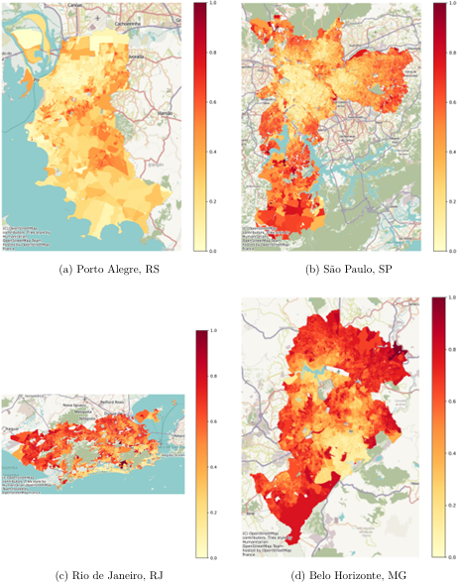
Figure 1: Composition of selected cities

A central contribution of this work lies in the explicit incorporation of statistical inference into segregation analysis. Traditionally, segregation indices have been treated as descriptive statistics, implicitly assuming that observed values represent fixed characteristics of a population. However, recent methodological developments challenge this assumption by emphasizing the stochastic nature of residential allocation processes and the resulting variability in segregation measures. The PySAL segregation module operationalizes this perspective by providing simulation-based inference frameworks for both single-value estimation and comparative analysis. These frameworks generate distributions of segregation indices under specified null hypotheses, enabling the computation of pseudo p-values and the assessment of statistical significance.

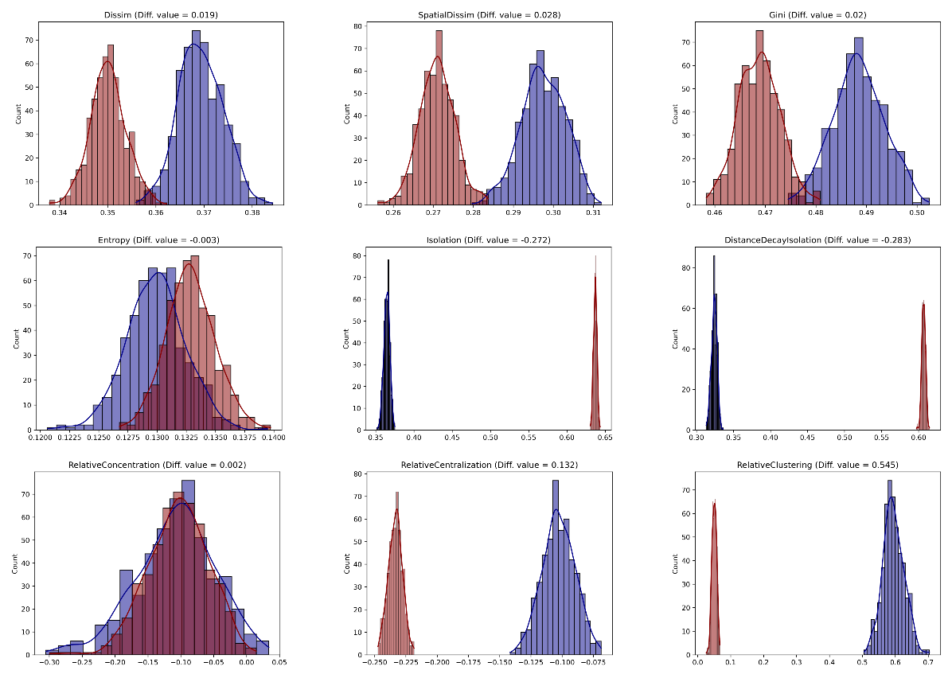

In this study, we employ multiple null hypothesis formulations, including systematic allocation (based on multinomial distributions with equal conditional probabilities), evenness (binomial allocation with constant global probability), and spatial permutation approaches. For comparative analysis between cities, we utilize random labeling approaches that reassign population compositions across spatial units, generating counterfactual distributions of segregation differences. This allows us to test whether observed disparities between cities are statistically meaningful or could arise under random allocation processes.
The Brazilian context provides a particularly compelling setting for this analysis. Unlike the United States, where segregation has historically been shaped by explicit institutional mechanisms, Brazilian cities exhibit patterns of spatial inequality that are more strongly associated with socioeconomic stratification, historical urban development, and informal housing dynamics. At the same time, growing evidence demonstrates that racial segregation—particularly affecting Black and Brown populations—is both persistent and consequential. By applying a multidimensional and inferential framework, this study moves beyond descriptive comparisons and provides a more rigorous assessment of the structure and significance of segregation in Brazil.
Our results reveal substantial heterogeneity across the four cities studied. São Paulo and Rio de Janeiro exhibit higher levels of segregation across multiple dimensions, reflecting their larger size, more complex spatial organization, and pronounced socioeconomic inequalities. Porto Alegre and Belo Horizonte, while still segregated, display comparatively lower levels of clustering and centralization. Across all cities, the dissimilarity and spatial dissimilarity indices indicate significant unevenness in the distribution of Black and Brown populations, while isolation measures highlight varying degrees of intra-group exposure. Spatial measures further reveal that clustering and concentration patterns differ markedly depending on the urban morphology and historical development of each city.
Importantly, the inferential results demonstrate that most observed segregation patterns are statistically significant under multiple null hypotheses, reinforcing the conclusion that these patterns are not merely artifacts of random allocation. However, the magnitude and significance of results vary depending on the choice of null model, underscoring the importance of careful methodological consideration. In some cases, measures that appear significant under a systematic allocation framework lose significance under spatial permutation, suggesting that spatial structure plays a critical role in shaping observed outcomes.
Beyond empirical findings, this study engages with ongoing methodological debates بشأن the interpretation of segregation indices and the validity of simulation-based inference. The flexibility of the PySAL framework, while powerful, introduces challenges related to the selection and interpretation of null hypotheses. Our analysis highlights that different inferential approaches can yield divergent conclusions, particularly in contexts characterized by small unit sizes or uneven population distributions. As such, we advocate for a cautious and transparent use of inferential tools, emphasizing the need to align methodological choices with substantive research questions.
In conclusion, this paper demonstrates the value of integrating open-source computational tools with rigorous inferential frameworks in the study of residential segregation. By applying these methods to the Brazilian context, we provide new insights into the spatial dimensions of racial inequality while contributing to the broader methodological literature. The results underscore the importance of moving beyond single-index, descriptive analyses نحو multidimensional and statistically grounded approaches. Future research should further explore the integration of spatial econometric and Bayesian methods, as well as the incorporation of longitudinal and multiscale perspectives, to deepen our understanding of the processes driving segregation in diverse urban settings.

Keywords: Residential Segregation; Spatial Analysis; PySAL; Brazil.

¹Departamento de Estatística, Instituto de Matemática e Estatística, UFRGS – renan.cortes@ufrgs.br

